A brief introduction to the three most cutting edge technologies and how they can be symbiotic

**We live in a globally connected society that strives for security, ease of existence, and advancement. And to achieve this usually turn to the adoption of cutting-edge technology.**

**What are the radical cutting edge technologies of now?**

The answer would probably involve **AI(Artificial Intelligence)**, **Blockchain**, or **IoT(Internet of Things)**.

### Blockchain

Blockchain was discovered in 2008 by Satoshi Nakamoto. It powers bitcoin mining. Miners are computers, or more generally processing units, tasked with running complicated algorithms to verify new blocks in return for a reward.

In the simplest terms, a blockchain is a combination of blocks. Blockchain can be of **private** or **public** chains. Public Blockchains are permissionless while Private Blockchains are permissioned in nature.

Permissioning comes with certain restrictions like who is allowed to access the chain. Examples of public blockchains are **Ethereum** and **Bitcoin**, while private includes **Hyperledger** and **R3 Corda**.

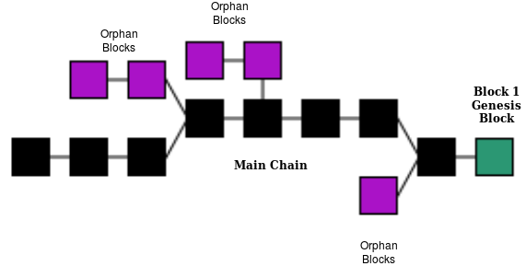

Here in the figure, it shows a rough representation of a blockchain. The first block is referred to as the genesis block. Each block is connected to the upcoming updated blocks to form a chain. The longest chain is called the main chain; all abandoned blocks are orphan blocks.

Blockchain works in a peer peer-to-peer network setting while adhering to a particular census(protocol). Data once recorded is unalterable without invasive change to the rest of the connected blocks and requires access to all the nodes over the chain retroactively.

In short, It is a Decentralized, distributed, and secured ledger to store and to access the data.

### Artificial Intelligence

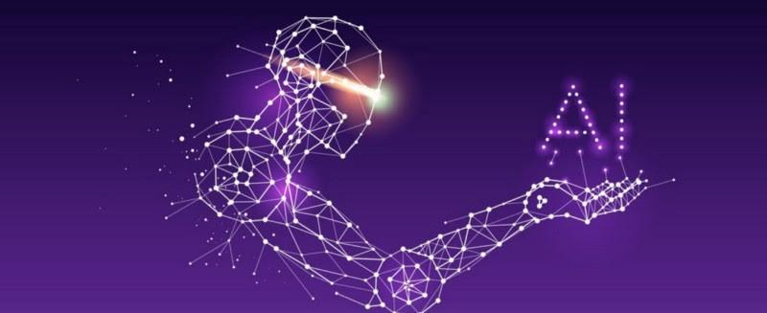

AI is the simulation of human intelligence processes by machines by making use of the collected data.

A little bit of trivia, AI goes back to Alan Turing who defined the Turing Test, to measure a machine’s ability to exhibit intelligent behavior equivalent to, or indistinguishable from, that of a human.

After a few years, John McCarthy( John McCarthy was an American computer scientist and cognitive scientist) who coined the term officially and is considered the father of Artificial Intelligence, at the famous Dartmouth Workshop.

There are three types of AI they are:

1. Weak AI or also called Artificial Narrow Intelligence (ANI), that allows computers to outperform humans in a few targeted tasks. An example is IBM Watson, Watson is a question-answering computer system capable of answering questions posed in natural language, developed in IBM’s DeepQA project(source wiki).
2. Strong AI or Artificial General Intelligence (AGI) is the ability of a machine to do the same cerebral work that a human being is capable of(under development).
3. Artificial Superintelligence (ASI), it is a machine that is capable of more intelligence than that of any gifted human mind in the world.

### Internet of Things

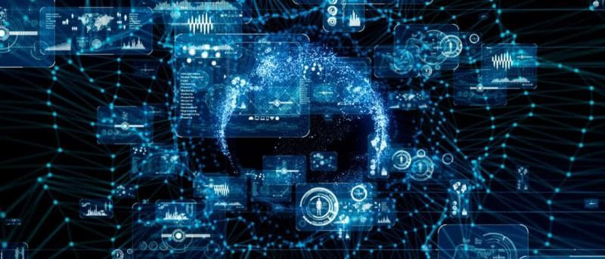

IoT is a system of interrelated computing devices with the ability to transfer data over a network with limited human intervention. In simple terms, it is all devices that are connected over the internet and thereby accessible from anywhere with a computational machine that has network access.

There is an interaction that is happening between devices. It is made possible via the use of sensors, actuators, microcontrollers, single-board computers.

Sensors and actuators interact with the world. Sensors deliver information to the microcontroller that forwards it to a place where it can be analyzed authorization. The data is sent directly to a web service somewhere on the internet.

### Security Pitfalls of IoT

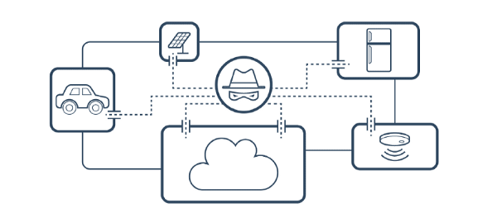

The Internet of Things is threatened by many vulnerabilities, the main of which is data security and hacking. Imagine if a hacker took over a self-driving car or the baby camera, the implications are worse.

There are examples of IoT failures and bad actors demonstrating the ability to exploit flaws in the system.

* Scandals surround Amazon-owned Ring. Researchers found that the IoT device was severely flawed. One gadget, in particular, allowed attackers to spy on families. Another one even exposed Wi-Fi passwords.
* Black Hat USA 2019, LeapPad Ultimate tablet was exposed by researchers. The device in question works as an educational tool for kids. They demonstrated that bad actors could exploit the flaws. The flaws that would make it possible to track the devices, send messages to children, or launch man-in-the-middle attacks.
* The 2009 Stuxnet computer virus that crippled the Iranian nuclear facility in Natanz, Iran.

### Overcoming Pitfalls

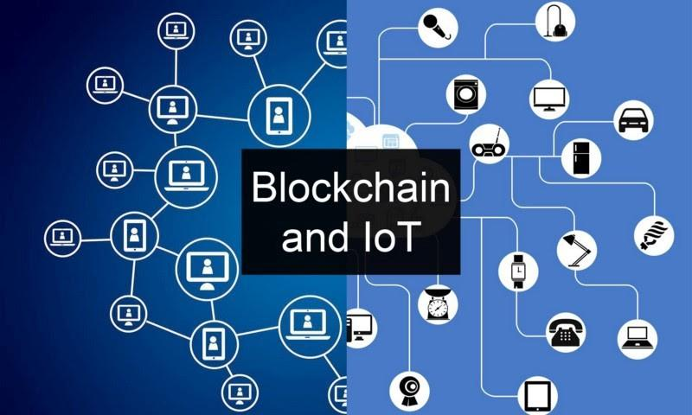

Security vulnerabilities in the context of the Internet of Things devices is an ongoing problem.

While biometrics and two-factor authorization are alternatives for security recommendations for IoT devices, Blockchain is an intriguing option for IoT security because of its considered effectiveness in the long run.

There are strong protections against data tampering in Blockchain also it will be able to lock access to the Internet of Things devices, and allow compromised devices in an IoT network to be shut down.

A blockchain start-up was backed by Hyundai recently. Its purpose is to design IoT security. It is called HDAC (Hyundai Digital Access Currency) and expects to create a permissioned private network.

In Brooklyn, NY they have established Brooklyn Microgrid. They have developed Exergy, a permissioned data platform, to create a localized energy marketplace. It transacts energy across existing grid infrastructure to spend excess solar energy by linking prosumer and consumer energy assets. Electricity is generated, stored, and transacted locally using IoT and Permissioned Blockchain simultaneously.

In the case of blockchain-backed IoT security, some issues need to be overcome.

1. Blockchain mining involves a large amount of processing power. IoT devices generally lack the processing power which is required.
2. Domestic IoT devices can have blockchain processing power and are hackable.

### Blockchain is the Future

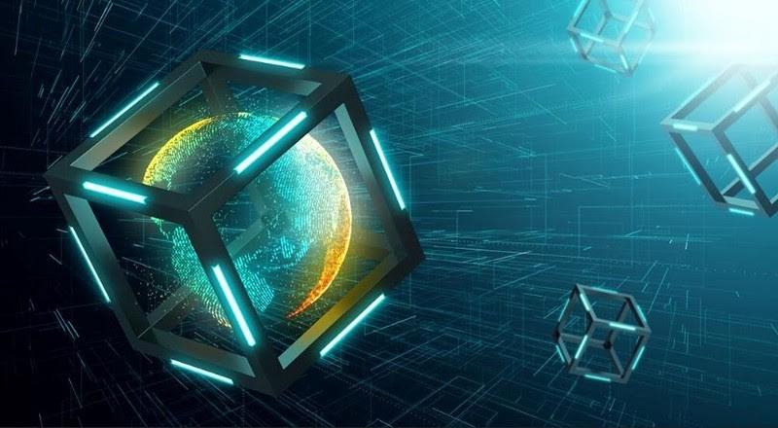

Blockchain adds to the changing digital infrastructure that impacts many areas. For example, the Finance, Insurance, Agriculture, and Banking industries have turned to adoption.

In India ICICI Bank, Axis Bank, and Yes Bank, which have been at the forefront of blockchain efforts in the country, and have joined JP Morgan’s blockchain platform, ‘the Interbank Information Network (IIN)’.

Blockchain has the potential of changing the way we work and communicate, making it more secure, efficient, and trustworthy. Data or transactions once embedded on the chain are open for audit and will have an untampered existence till the end of time.

One of the best properties of Blockchain is that it helps in the removal of third parties in any transaction or arrangement.

Disrupting an environment that was thus far was centralized.

Since the launch of the Ethereum platform, there has been the utilization of blockchain technology for different applications. Nowadays almost every company has a team working on blockchain technology. Companies are trying out different uses for it in a multitude of applications. And are seeing an influx of capital in this domain. It proves that adoption is happening slowly but surely.